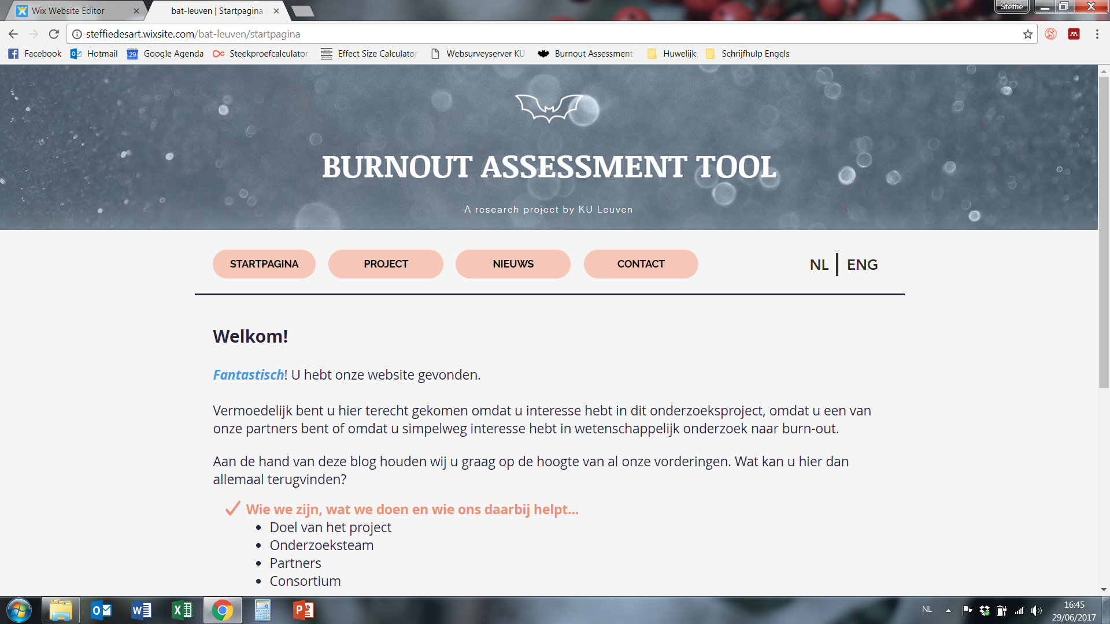

# Consortium members per July 2024

|  |  |  |  |
| --- | --- | --- | --- |
| **Country** | **City** | **Name** | **Email** |
|  |  |  |  |
| Austria | Innsbruck | Jürgen Glaser | [juergen.glaser@uibk.ac.at](mailto:juergen.glaser@uibk.ac.at) |
| Belgium | Leuven | Steffie Desart | [steffie.desart@idewe.be](mailto:steffie.desart@idewe.be) |
| Brazil | Porto Alegre | Ana Vazquez | [vazquez.ac@gmail.com](mailto:vazquez.ac@gmail.com) |
| Brazil | Porto Alegre | Claudio Hutz | [Claudio.hutz@gmail.com](mailto:Claudio.hutz@gmail.com) |
| Bulgaria | Sofia | Kalin Yanev | [kalinyanev@yahoo.com](mailto:kalinyanev@yahoo.com) |
| Bosnia | Banja Luka | Biljana Mirkovic | [bixi.mirkovic@gmail.com](mailto:bixi.mirkovic@gmail.com) |
| China | Zhejiang | Qiao Hu | [qiaohu2005@aliyun.com](mailto:qiaohu2005@aliyun.com) |
| China | Zhejiang | Jun-ming Dai | [jmdai@fudan.edu.cn](mailto:jmdai@fudan.edu.cn) |
| Croatia | Zagreb | Bojana Knezevic | [bojkneze@gmail.com](mailto:bojkneze@gmail.com) |
| Croatia | Zagreb | Darja Maslić-Seršić | dmaslic@ffzg.hr |
| Croatia | Zagreb | Jasmina Tomas | [jtomas@ffzg.hr](C:\\Users\\User\\Downloads\\jtomas@ffzg.hr) |
| Czech Rep. | Brno | Jakub Procházka | [jak.prochazka@mail.muni.cz](C:\\Users\\User\\Downloads\\jak.prochazka@mail.muni.cz) |
| Ecuador | Guayaquil | Ronald Campoverde | [recampov@espol.edu.ec](mailto:recampov@espol.edu.ec) |
| Ecuador | Guayaquil | M.del Carmen Lapo | [maria.lapo@cu.ucsg.edu.ec](mailto:maria.lapo@cu.ucsg.edu.ec) |
| Ecuador | Guayaquil | Alexandra Portalanza | [aportalanza@cu.ucsg.edu.ec](mailto:aportalanza@cu.ucsg.edu.ec) |
| Finland | Helsinki | Janne Kaltiainen | [janne.kaltiainen@ttl.fi](C:\\Users\\User\\Downloads\\janne.kaltiainen@ttl.fi) |
| Finland | Helsinki | Jari Hakanen | [Jari.Hakanen@ttl.fi](mailto:Jari.Hakanen@ttl.fi) |
| Finland | Tampere | Anne Mäkikangas | anne.makikangas@tuni.fi |
| France | Paris | Ilona Boniwell | [i.boniwell@positran.fr](mailto:i.boniwell@positran.fr) |
| Germany | München | Jürgen Glaser | [Juergen.Glaser@uibk.ac.at](https://kuleuven-my.sharepoint.com/personal/hans_dewitte_kuleuven_be/Documents/Documents/1.%20PC%20Psy%2018%20okt%202021%20My%20Documents/Wilmar%20Schaufeli/6.%20BAT%20international%20consortium%20April%202024/Juergen.Glaser@uibk.ac.at) |
| Hungary | Budapest | Ezther Nagy | [nagyeszter@erg.bme.hu](C:\\Users\\User\\Downloads\\nagyeszter@erg.bme.hu) |
| Iceland | Reykjavik | Linda Bára Lyosdottir | [lindabl@ru.is](mailto:lindabl@ru.is) |
| Iceland | Reykjavik | Gudrun Eriksdottir | gudrunrakel@virk.is |
| Iceland | Reykjavik | Berglind Stefansdottir | [berglind@virk.is](mailto:berglind@virk.is) |
| Ireland | Dublin | Janine Bosak | [janine.bosak@dcu.ie](mailto:janine.bosak@dcu.ie) |
| Israel | Tel Aviv | Sharon Toker | [tokersha@post.tau.ac.il](mailto:tokersha@post.tau.ac.il) |
| Italy | Bologna | Greta Mazzetti | [greta.mazzetti3@unibo.it](mailto:greta.mazzetti3@unibo.it) |
| Italy | Rome | Chiara Consiglio | [chiara.consiglio@uniroma1.it](mailto:chiara.consiglio@uniroma1.it) |
| Iran | Mashad | Abbas Firoozabadi | abbas.firoozabadi@maastrichtuniversity.nl |
| Japan | Tokyo | Akihito Shimazu | [cym04036@gmail.com](http://cym04036@gmail.com) |
| Japan | Tokyo | Keiko Sakakibara | [sakakibara@toyo.jp](mailto:sakakibara@toyo.jp) |
| Japan | Helsinki | Hiroyuki Toyama | [toyama.hiroyuki@helsinki.fi](mailto:toyama.hiroyuki@helsinki.fi) |
| Lithuania | Vilnius | Jurgita Lazauskaitė-Zabielskė | [jurgita.lazauskaite@fsf.vu.lt](mailto:jurgita.lazauskaite@fsf.vu.lt) |
| Malaysia | Kuala Lumpur | Harris Shuh Hamid | harris75@um.edu.my |
| Malta | Malta | Vincent Cassar | vincent.cassar@um.edu.mt |
| Netherlands | Maastricht | Angelique de Rijk | angelique.derijk@maastrichtuniversity.nl |
| New Zealand | Canterbury | Katharina Naswall | katharina.naswall@canterbury.ac.nz |
| New Zealand | Auckland | Jarrod Haar | J.Haar@massey.ac.nz |
| Norway | Trondheim | Marit Christensen | marit.christensen@ntnu.no |
| Norway | Trondheim | Torhild Sørengaard | [torhild.sorengaard@bi.no](mailto:torhild.sorengaard@bi.no) |
| Norway | Trondheim | Leon De Beer | [leondeb@ntnu.no](mailto:leondeb@ntnu.no) |
| Norway | Stavanger | Espen Olsen | [espen.olsen@uis.no](mailto:espen.olsen@uis.no) |
| Peru | Lima | Patric Palmieri | [patrick.palmieri@jbisa.org](http://patrick.palmieri@jbisa.org) |
| Poland | Gdansk | Beata Basínska | [bbasinska@swps.edu.pl](mailto:bbasinska@swps.edu.pl) |
| Poland | Katowice | Ewa Gruszcynska | [egruszczynska@swps.edu.pl](http://egruszczynska@swps.edu.pl) |
| Portugal | Lisbon | Silvia Silva | [silvia.silva@iscte.pt](mailto:silvia.silva@iscte.pt) |
| Portugal | Lisbon | Fransisca de Carvalho | [fmsac@iscte-iul.pt](C:\\Users\\User\\Downloads\\fmsac@iscte-iul.pt) |
| Romania | Timisoara | Coralia Sulea | [coralia.sulea@e-uvt.ro](mailto:coralia.sulea@e-uvt.ro) |
| Romania | Bukarest | Dragos Iliescu | [dragos.iliescu@fpse.unibuc.ro](C:\\Users\\User\\Downloads\\dragos.iliescu@fpse.unibuc.ro) |
| Romania | Bukarest | Bogdan Oprea | [bogdan.oprea@fpse.unibuc.ro](mailto:bogdan.oprea@fpse.unibuc.ro) |
| Romania | Timișoara | Laurentiu Maricutoiu | laurentiu.maricutoiu@e-uvt.ro |
| Romania | Timișoara | Bianca Popescu | [bianca.popescu95@e-uvt.ro](C:\\Users\\User\\Downloads\\bianca.popescu95@e-uvt.ro) |
| Russia | Moscow | Evgeny Osin | [evgeny.n.osin@gmail.com](mailto:evgeny.n.osin@gmail.com) |
| Russia | Moscow | Maina Miletich | [miletich.maina@gmail.com](http://miletich.maina@gmail.com) |
| Russia | Moscow | Nikita Kolachev | [nikita.kolachev@yandex.ru](C:\\Users\\User\\Downloads\\nikita.kolachev@yandex.ru) |
| Serbia | Belgrade | Ivana Petrovic | [ipetrovi@f.bg.ac.rs](mailto:ipetrovi@f.bg.ac.rs) |
| Singapore | Singapore | Jorge Sinval | [jorge.sinval@nie.edu.sg](mailto:jorge.sinval@nie.edu.sg) |
| Slovakia | Ruzomberok | Katarína Kohútová | katarina.kohutova@ku.sk |
| Slovakia | Kosice | Pavol Kačmár | [pavol.kacmar@upjs.sk](https://kuleuven-my.sharepoint.com/personal/hans_dewitte_kuleuven_be/Documents/Documents/1.%20PC%20Psy%2018%20okt%202021%20My%20Documents/Wilmar%20Schaufeli/6.%20BAT%20international%20consortium%20April%202024/pavol.kacmar@upjs.sk) |
| Slovenia | Maribor | Sara Tement | [sara.tement@um.si](mailto:sara.tement@um.si) |
| South Africa | Cape Town | Theo Swart | tswart@netactive.co.za |
| South Africa | Potchefstroom | Leon de Beer | [leondb@gmail.com](mailto:leondb@gmail.com) |
| South Korea | Seoul | Soohyun Cho | [jenif2r@naver.com](mailto:jenif2r@naver.com) |
| Spain | Castellon | Marisa Salanova | [salanova@uji.es](mailto:salanova@uji.es) |
| Sweden | Gothenburg | Emina Hadzibajramovic | emina.hadzibajramovic@vgregion.se |
| Sweden | Gothenburg | Kristina Glise | [kristina.glise@vgregion.se](mailto:kristina.glise@vgregion.se) |
| Sweden | Stockholm | Emma Brulin | emma.brulin@ki.se |
| Sweden | Sockholm | Jörgen Herlofson | [j.herlofson@gmail.com](http://j.herlofson@gmail.com) |
| Thailand | Bangkok | Oraphan Tatha | oraphan.tatha@gmail.com |
| Turkey | Istanbul | Ömer Erdem Koçak | [kocak.omerdem@gmail.com](mailto:kocak.omerdem@gmail.com) |
| Turkey | Istanbul | Oguz Gencay | [oguzgencay@windowslive.com](mailto:oguzgencay@windowslive.com) |
| UK | Sheffield | Karina Nielsen | [k.m.nielsen@sheffield.ac.uk](mailto:k.m.nielsen@sheffield.ac.uk) |
| UK | Bedfordshire | Gail Kinman | gail.kinman@bbk.ac.uk |
| Ukraine | Kiev | Karine Malsheva | [karinemalysheva@gmail.com](mailto:karinemalysheva@gmail.com) |
| USA | Athens, GA | Malissa Clark | [clarkm@uga.edu](http://clarkm@uga.edu) |

# Coordinators

|  |  |  |  |
| --- | --- | --- | --- |
| **Country** | **City** | **Name** | **Email** |
|  |  |  |  |
| Belgium | Leuven | Hans De Witte | [hans.dewitte@kuleuven.be](mailto:hans.dewitte@kuleuven.be) |
| Netherlands | Leuven/Utrecht | Wilmar Schaufeli | [w.schaufeli@uu.nl](mailto:w.schaufeli@uu.nl) |

No longer active